Part A
Name:-
Roll No:-
Subject:- Data Structures and Algorithms
Program: B Tech/MBA Tech CE 2nd Year
Aim:
Implementation of various array operations like traversal, insertion and deletion using any real life application.
Prerequisite: C++ Programming
Outcome: To implement arrays and its operations.
Theory: An array is defined as the collection of similar type of data items stored at contiguous memory locations. The array is the simplest data structure where each data element can be randomly accessed by using its index number. Arrays are the derived data type which can store the primitive type of data such as int, char, double, float, etc.
Declaration of C/C++ Array
data_type array_name[array_size];
int marks[5];
int marks[5]={20,30,40,50,60};
OPERATIONS ON ARRAY
- Traversing an array
- Inserting an element in an array
- Searching an element in an array
- Deleting an element from an array

Traversing an array

Algorithm for array traversal
Step 1: [INITIALIZATION] SET I= lower_bound
Step 2: Repeat Steps 3 to 4 while I<= upper_bound
Step 3: Apply Process to A[I]
Step 4: SET I=I+1
[END OF LOOP]
Step 5: EXIT

Inserting an Element in an Array
- Algorithm to insert at the end
Step 1: Set upper_bound = upper_bound+1
Step 2: Set A[upper_bound] = VAL
Step 3: EXIT
- Algorithm to Insert an Element in the Middle of an Array
Step 1: [INITIALIZATION] SET I=N
Step 2: Repeat Steps 3 and 4 while I>= POS
Step 3: SET A[I + 1] = A[I]
Step 4: SET I=I–1
[END OF LOOP]
Step 5: SET N=N+1
Step 6: SET A[POS] = VAL
Step 7: EXIT
Deleting an Element from an Array
- Algorithm
- Step 1: [INITIALIZATION] SET I= POS
- Step 2: Repeat Steps 3 and 4 while I<=N–1
- Step 3: SET A[I] = A[I+1]
- Step 4: SET I=I+1
- [END OF LOOP]
- Step 5: SET N=N–1
- Step 6: EXIT

Procedure:
- Open CodeBlock editor or visual studio editor and write the code in C++.
- Complile and run the code
Instructions:
- Copy code & paste in code section and output of Part B.

Part B
Code:
Combinedcode menu driven:
#include <iostream>
using namespace std;

const int MAX_SIZE = 10;
int arr[MAX_SIZE] = {1, 2, 3, 4, 10};
int n = 5;

void traverse();
void insert();
void search();
void deleteElement();

int main() {
int counter;
do {
cout << "1. Traverse 2. Insert 3. Search 4. Delete 5. Exit" << endl;
cout << "Enter choice: ";
cin >> counter;

switch (counter) {
case 1:
traverse();
break;
case 2:
insert();
break;
case 3:
search();
break;
case 4:
deleteElement();
break;
case 5:
cout << "Exiting program." << endl;
break;
default:
cout << "Operation does not exist" << endl;
break;
}
cout << endl; // Add newline for clarity
} while (counter != 5);

return 0;
}

void traverse() {
if (n == 0) {
cout << "Array is empty" << endl;
return;
}
cout << "Array elements: ";
for (int i = 0; i < n; i++) {
cout << arr[i] << " ";
}
cout << endl;
}

void insert() {
if (n >= MAX_SIZE) {
cout << "Array is full, cannot insert" << endl;
return;
}

int x, pos;
cout << "Enter value to insert: ";
cin >> x;
cout << "Enter position (0 to " << n << "): ";
cin >> pos;

if (pos < 0 || pos > n) {
cout << "Invalid position" << endl;
return;
}

for (int j = n - 1; j >= pos; j--) {
arr[j + 1] = arr[j];
}
arr[pos] = x;
n++;

cout << "Array after insertion: ";
for (int i = 0; i < n; i++) {
cout << arr[i] << " ";
}
cout << endl;
}

void search() {
int x;
cout << "Enter value to search: ";
cin >> x;

bool found = false;
int index = -1;
for (int i = 0; i < n; i++) {
if (arr[i] == x) {
found = true;
index = i;
break;
}
}

if (found) {
cout << "Element " << x << " found at index " << index << endl;
} else {
cout << "Element not found" << endl;
}
}

void deleteElement() {
if (n == 0) {
cout << "Array is empty, cannot delete" << endl;
return;
}

int pos;
cout << "Enter position to delete (0 to " << n - 1 << "): ";
cin >> pos;

if (pos < 0 || pos >= n) {
cout << "Invalid position" << endl;
return;
}

for (int j = pos; j < n - 1; j++) {
arr[j] = arr[j + 1];
}
n--;

cout << "Array after deletion: ";
for (int i = 0; i < n; i++) {
cout << arr[i] << " ";
}
cout << endl;
}

1.
#include<iostream>
using namespace std;

int main(){
int arr[6] = {1, 2, 3, 4, 10};
int n = 5;

for(int i=0; i<n; i++) {
cout<<arr[i]<<" ";
}

}
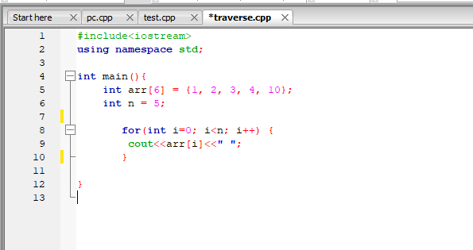

2.
#include<iostream>
using namespace std;

int main(){
int arr[6] = {1, 2, 3, 4, 10};
int n = 6;
int x, pos;
cout<<"Enter value to insert: ";
cin>>x;

cout<<"Enter position: ";
cin>>pos;

for(int j=n-1; j>=pos; j--) {
arr[j+1] = arr[j];
}
arr[pos] = x;
n = n + 1;

for(int i=0; i<6; i++) {
cout<<arr[i]<<" ";
}

}

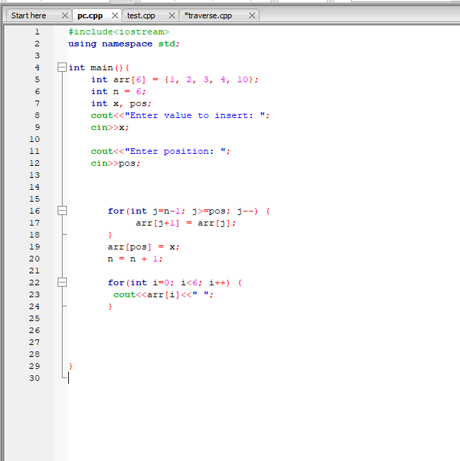

3.
#include<iostream>
using namespace std;

int main(){
int arr[5] = {1, 2, 3, 4, 10};
int n = 5;
int x;
cout<<"Enter value to search: ";
cin>>x;

for(int i=0; i<5; i++) {
if(arr[i] == x) {
cout<<"Element found "<<x;
break;
} else {
cout<<"Element not found ";
break;
}

}
}
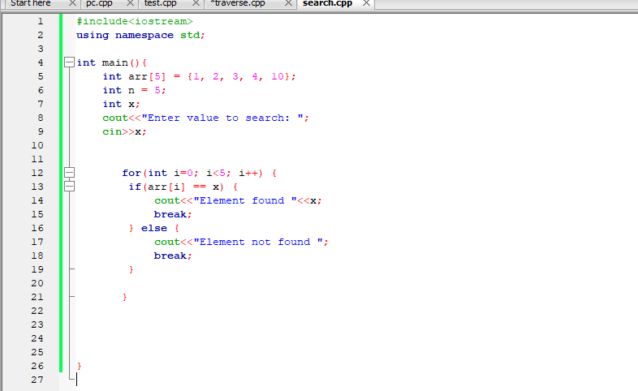

4.
#include<iostream>
using namespace std;

int main(){
int arr[5] = {1, 2, 3, 4, 10};
int n = 5;
int pos;

cout<<"Enter position: ";
cin>>pos;

for(int j=pos; j<n-1; j++) {
arr[j] = arr[j+1];
}
n--;

for(int i=0; i<4; i++) {
cout<<arr[i]<<" ";
}
}
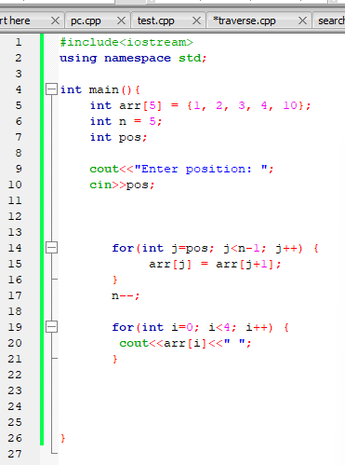

Output:

Main code:
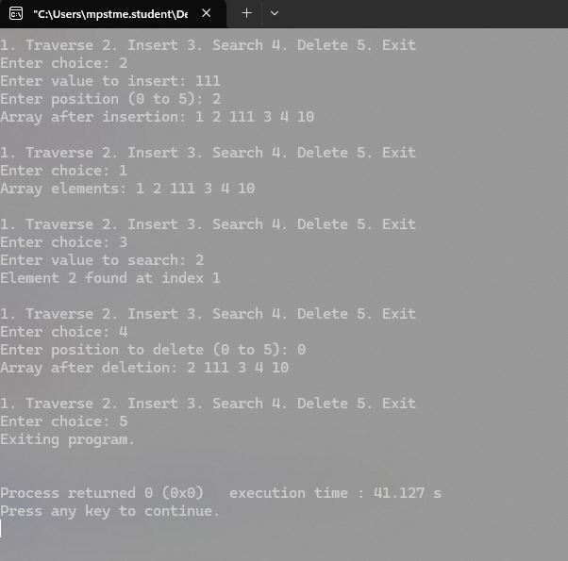
1. 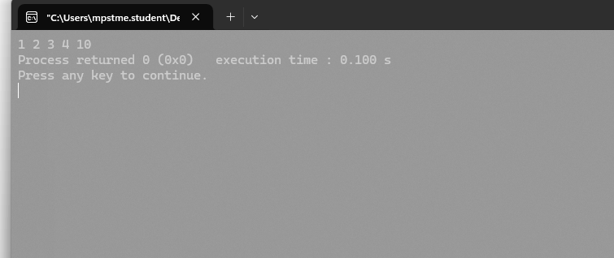

2.
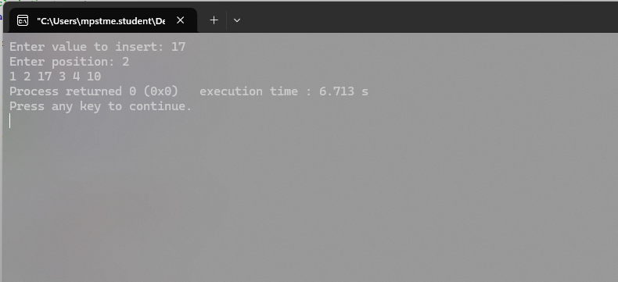

3.
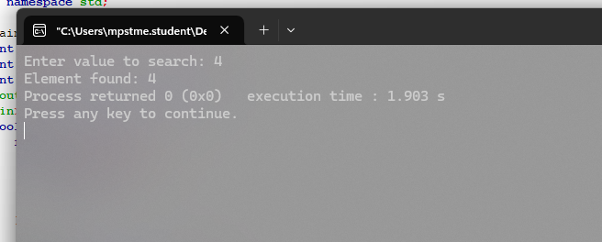

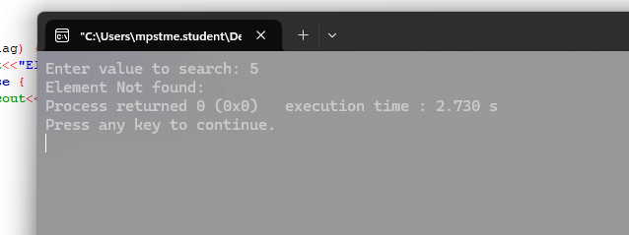

4.
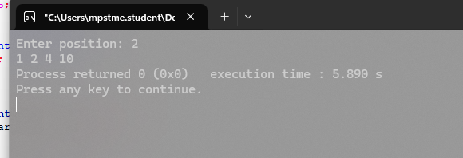
Observation & Learning:
Write your Observations & Learning after performing task
Answer Following Question

Conclusion:
We successfully implemented C++ program on arrays and its operations.
I learned how to insert operation by shifting element to the right and vice versa for delete. For search I kept a bool flag to keep in check if number exist and as for traverse I used a loop to print respective element.

